K'PRESSO COFFEE - EXPORT PRICE LIST - DISTRIBUTORS - EXWORK - PORTUGAL - EUROS €

EAN CODE | ARTICLE | PHOTO | TRANSPORTATION UNIT | INVOICE UNIT | NET PRICE IN EUROS PER EACH INVOICE UNIT - EXW PORTUGAL | NUMBER OF INVOICE UNITS PER EUROPALLET 80 CM X 120 CM | NUMBER OF INVOICE UNITS PER SEA SHIPMENT PALLET 100 CM X 120 CM
HORECA RANGE
COFFEE BEANS
 | VENDING |  | 1 CASE X 10 KGS | KG | 6,74 € | 480 | 700
K'PRESSO - COFFEE CAPSULES (NESPRESSO COMPATIBLES)
15600718469001 | K'PRESSO BRASIL 5GR | 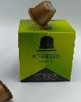 | 1 X 6 X 10 CAPSULES | 1 X 10 CAPSULES | 1,50 € | 1 254 | 2 820
15600718469032 | K'PRESSO ANGOLA 5GR | 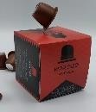 | 1 X 6 X 10 CAPSULES | 1 X 10 CAPSULES | 1,50 € | 1 254 | 2 820
15600718469018 | K'PRESSO COLOMBIA 5GR | 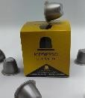 | 1 X 6 X 10 CAPSULES | 1 X 10 CAPSULES | 1,50 € | 1 254 | 2 820
15600718469025 | K'PRESSO CUBA 5 GR | 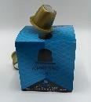 | 1 X 6 X 10 CAPSULES | 1 X 10 CAPSULES | 1,80 € | 1 254 | 2 820

PRICES ARE EXWORK PORTUGAL IN EUROS
PAYMENT AND DELIVERY TERMS:
ADVANCE PAYMENT AFTER GLOBAL STOCKS SENDING PROFORMA INVOICE

